Ai assisted coding Assignment-14.1
Name:n.Vaishnavi
Batch-44
HTNO:2303a52405

Task 1 – Portfolio Website
Prompt: Design a personal portfolio website with sections for About Me, Projects, and Contact. Include a navigation bar with smooth scrolling and create a responsive layout using CS
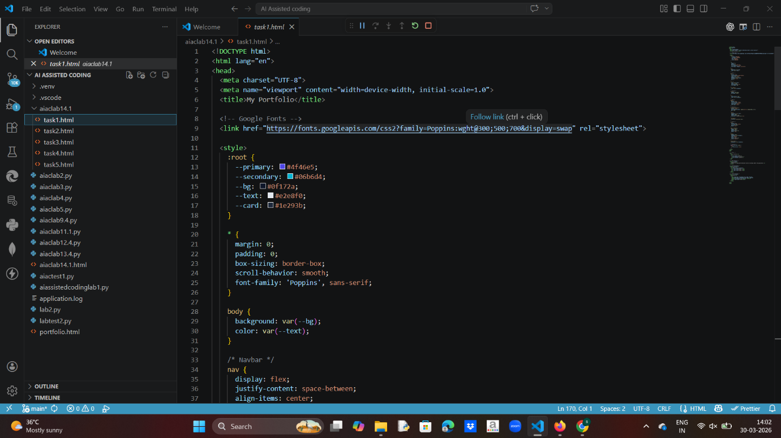
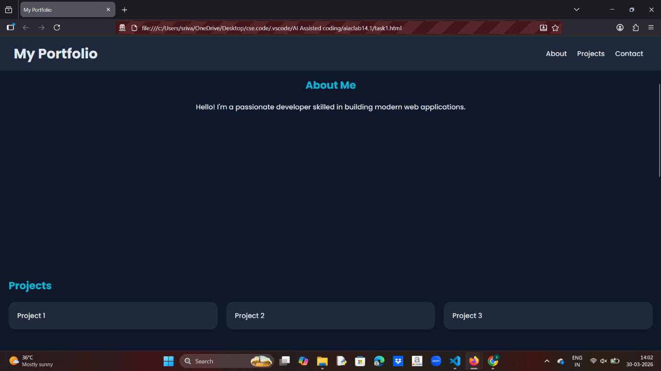
Observation: The website displays all sections clearly with smooth navigation. The layout is responsive and adjusts well to different screen sizes. The design is simple, clean, and user-friendly.

Task 2 – Online Store Product Page
Prompt: Create a product display page that shows product image, title, and price with an “Add to Cart” button. Add hover effects and display an alert when the button is clicked.
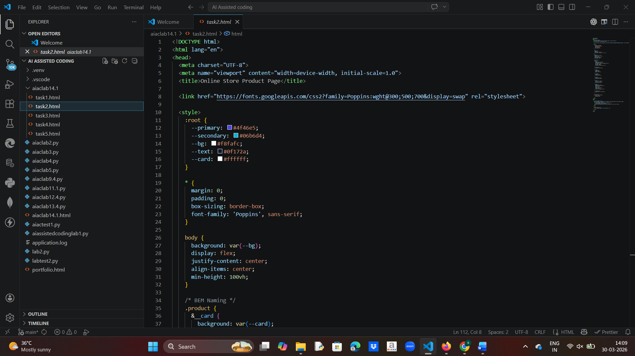
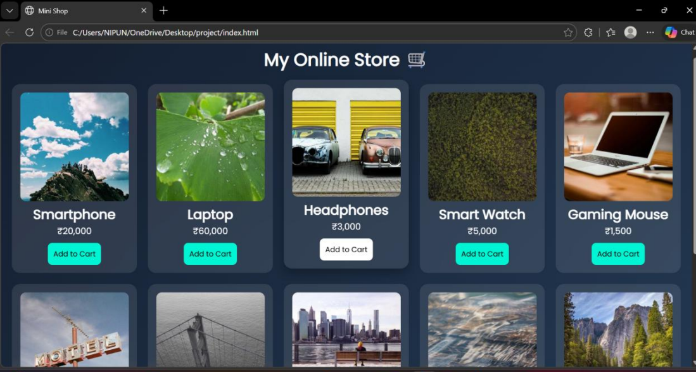
Observation: The product is displayed in a card format with a hover effect that improves visual interaction. The “Add to Cart” button works correctly and shows a confirmation alert. The layout is neat and responsive.

Task 3 – Event Registration Form
Prompt: Build an event registration form to collect name, email, phone number, and session selection. Add JavaScript validation and ensure proper labeling for accessibility.
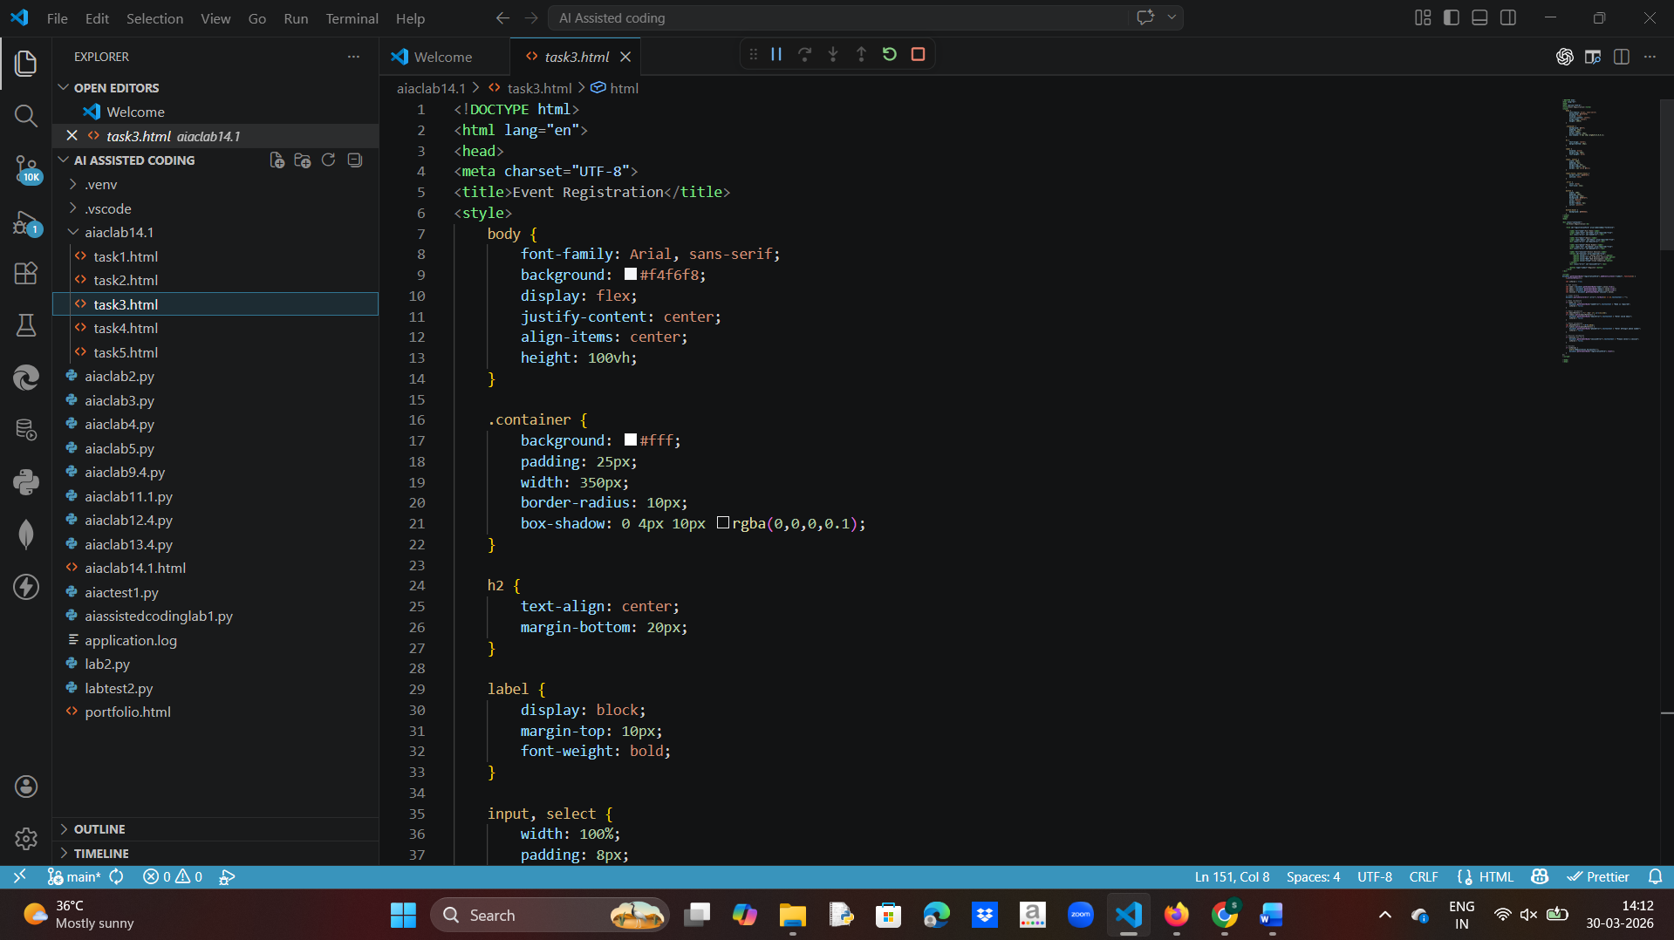
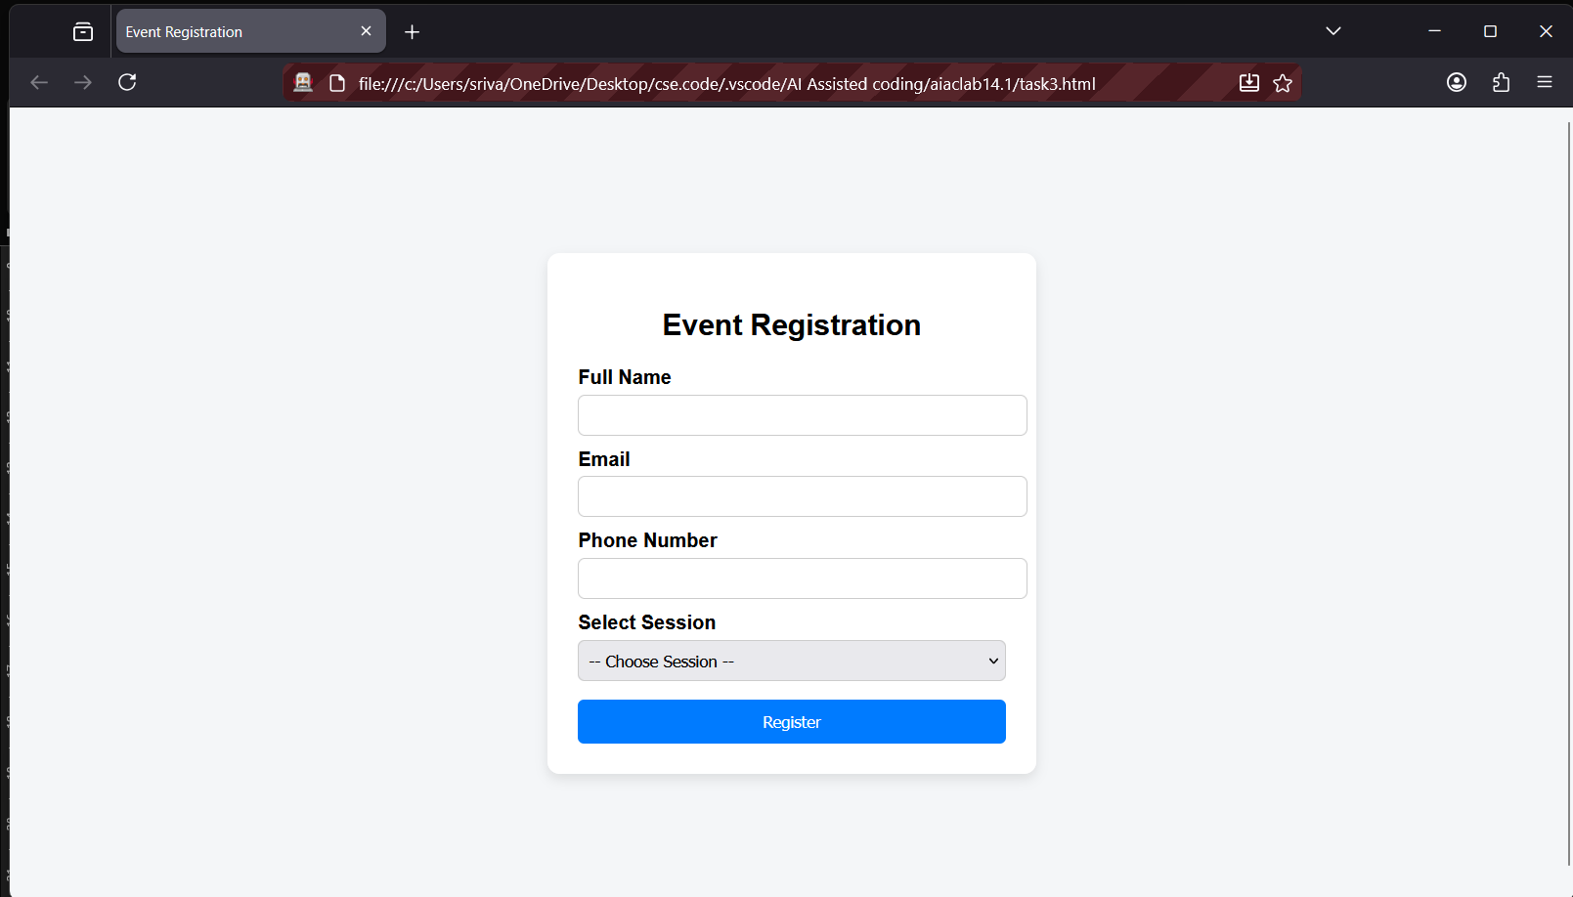
Observation: The form collects user data efficiently and prevents submission when required fields are empty. Validation works correctly, and the structure is easy to understand and use.
Task 4 – Resume Website
Prompt: Create a one-page resume website including Profile Summary, Skills, Education, and Experience sections. Use CSS Grid to align the layout and maintain a professional design.
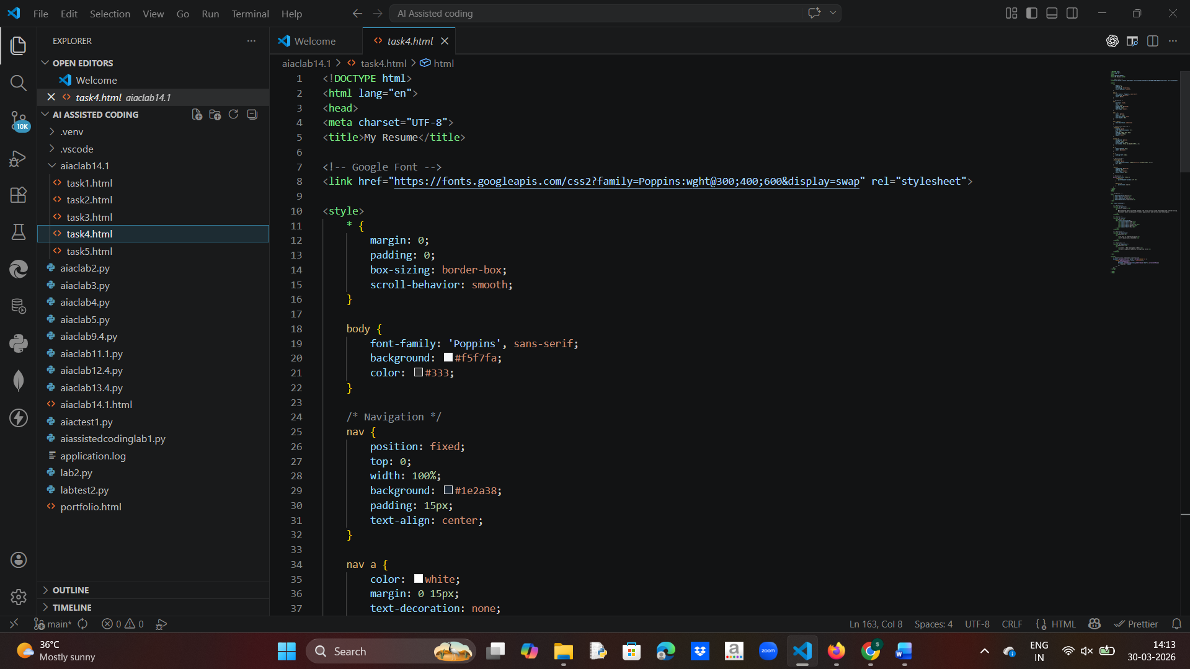
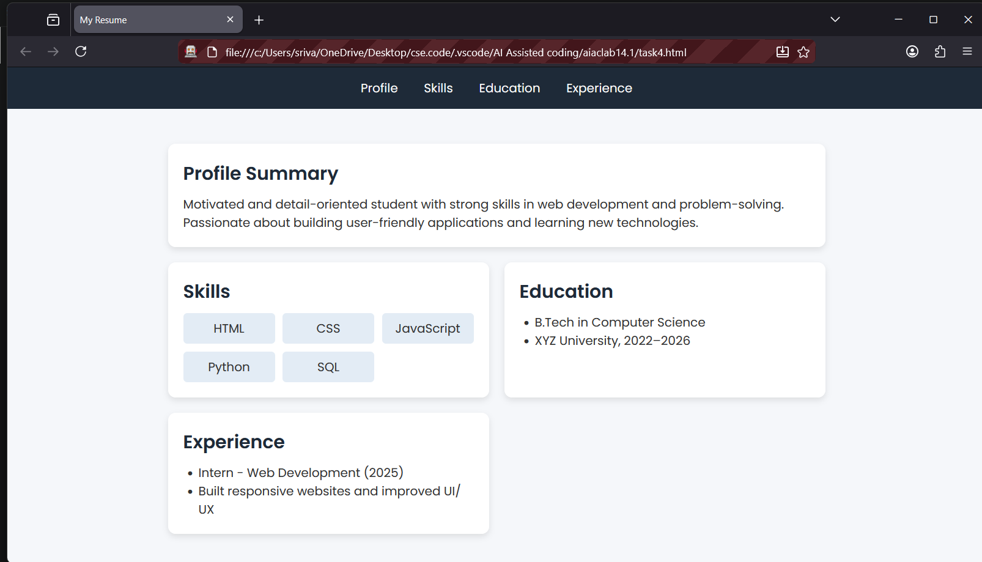
Observation: The resume layout is well-structured and organized using grid. All sections are clearly visible and easy to read. The design looks professional and clean.
Task 5 – Restaurant Menu Page
Prompt: Design a restaurant menu page displaying food items with name, description, and price. Use a card-based layout with hover effects and ensure responsiveness.
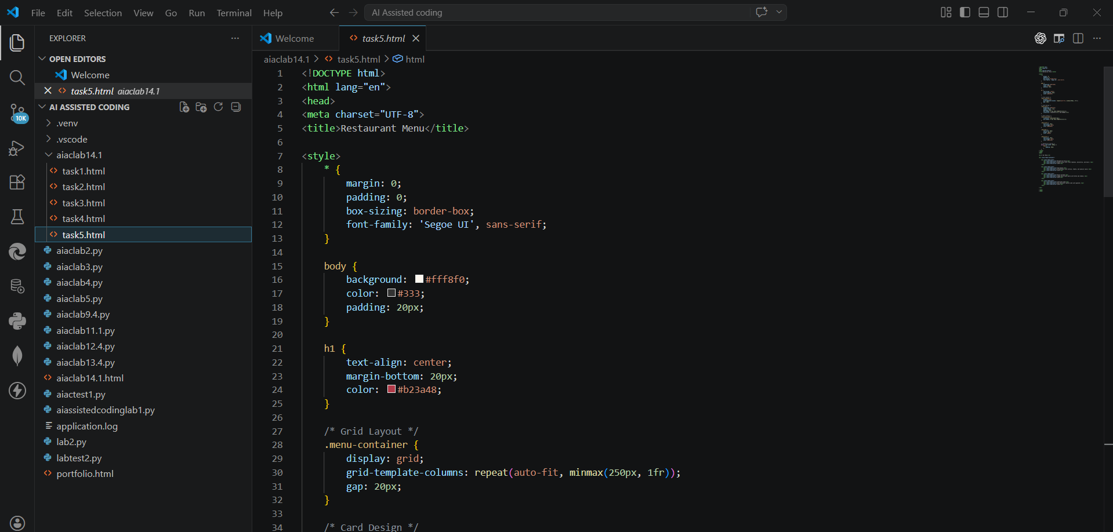
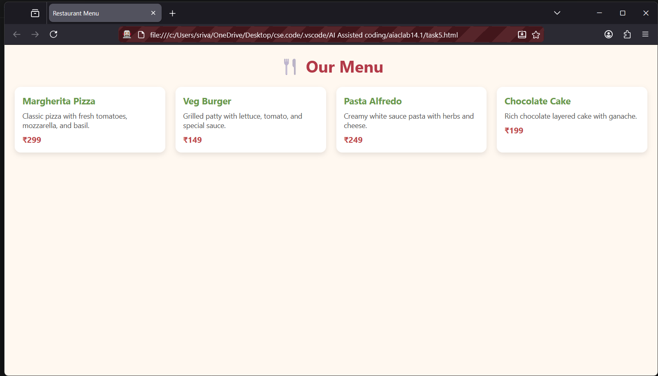
Observation: Menu items are displayed in an attractive card format. Hover effects enhance user experience. The layout is flexible and adapts well to different screen sizes.

